# MySQL Server Linux Installation Guidelines

This document consists of guidelines and steps for installing MySQL server on a Linux distribution. The installation will be done using the **MySQL APT Repository**. The following steps are shown on **Ubuntu**, but the installation guide is **generic**.

### Step 1. Download the MySQL APT Repository

The MySQL APT(**Advanced Package Tool**) Repository is a tool which provides us a simple way to install MySQL Community Server. First, we need to download and upgrade it in order to continue with the server installation.

Go to the MySQL APT Repository [download page](https://dev.mysql.com/downloads/repo/apt/) and download the given package as shown in the screenshot below. It is found on the bottom of the webpage.



Click the “Download” button and save the package file to a desired path.

### Step 2. Install MySQL APT Repository

1. Open the folder in which you’ve downloaded the package from the previous step. **Open a terminal there** and run the following command **replacing the “version-specific-package-name.deb” with the name of the package you’ve downloaded.**

**sudo dpkg -i version-specific-package-name.deb**

F

For example:

**sudo dpkg -i mysql-apt-config_0.8.7-1_all.deb**

You will be asked to provide **administrator** **password** in order to give permission to install.

1. After you run the command a **Package configuration window** will appear where you’ll have to configure which MySQL components you want to install.

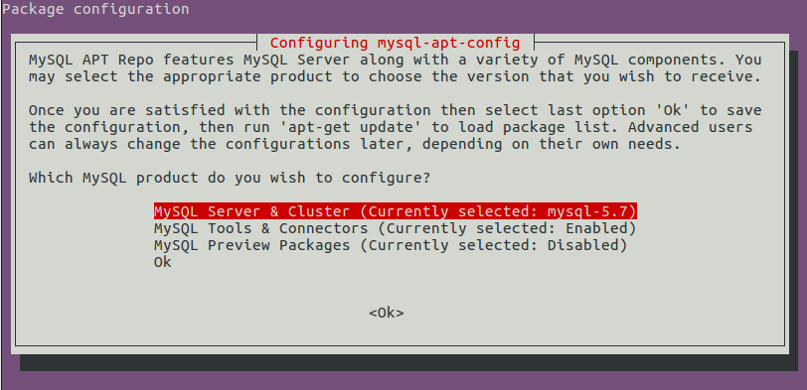

**The version of MySQL that we are going to work with is 5.7 so explicitly select mysql-5.7.**

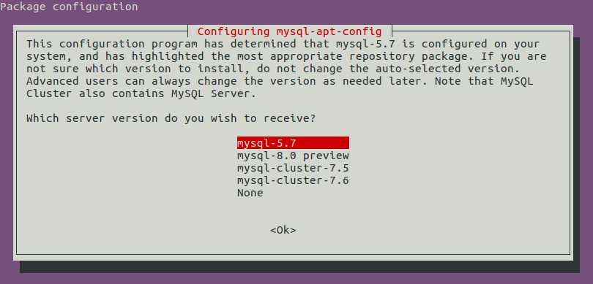

**Go back and select “Ok”.**

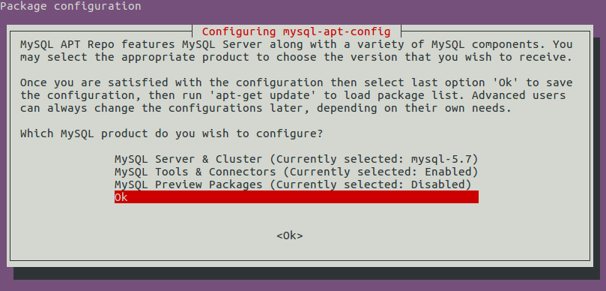

### Step 3. Update MySQL APT Repository

**This step is very important and mandatory**. We need to update the MySQL APT Repository with the following command:

**sudo apt-get update**

### Step 4. Installing MySQL with APT

We install MySQL with the following command:

**sudo apt-get install mysql-server**

You will be asked again to **provide administrator password** and a **root password** for the server. Make sure you remember it to connect later.

### Step 5. Running the MySQL Service

After completing the installation of MySQL Community Server, it will automatically run. You can check it’s status running this command:

**sudo service mysql status**

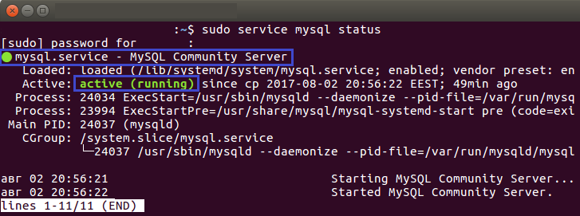

You can **stop** the service running:

**sudo service mysql stop**

Or **start** it:

**sudo service mysql start**